Unit 1 My Future

A
2. What I am interested in is animals.
3. What I am interested in is mountain climbing.
4. What I am interested in is music.

B
2. Another one of my dreams is to make movies.
3. Another one of my dreams is to play the violin.
4. Another one of my dreams is to become a writer.

C
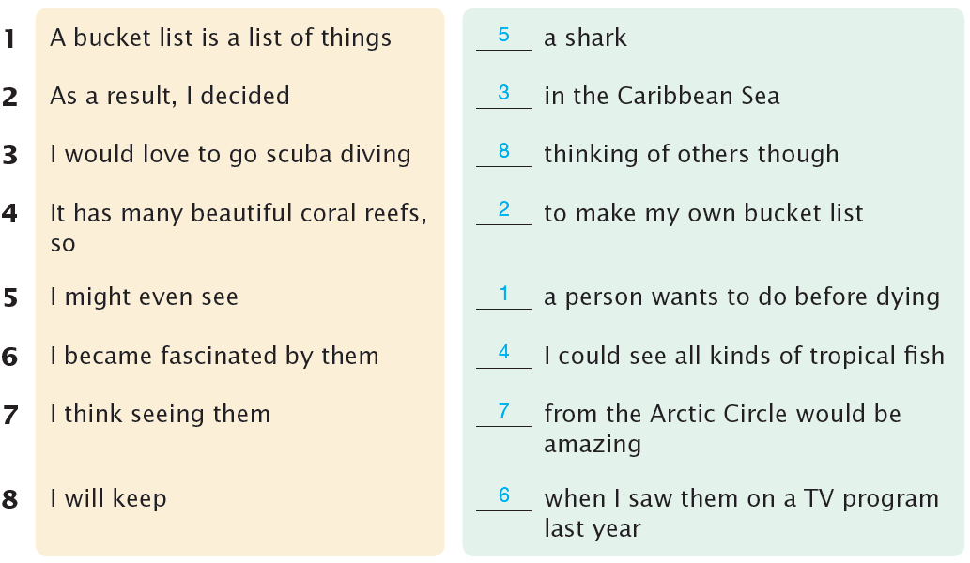
1. A bucket list is a list of things a person wants to do before dying.
2. As a result, I decided to make my own bucket list.
3. I would love to go scuba diving in the Caribbean Sea.
4. It has many beautiful coral reefs, so I could see all kinds of tropical fish.
5. I might even see a shark.
6. I became fascinated by them when I saw them on a TV program last year.
7. I think seeing them from the Arctic Circle would be amazing.
8. I will keep thinking of others though.

Unit 2 My Favorite Website

A
2. Google is a website focusing on online searches.
3. YouTube is a website focusing on sharing videos.
4. Amazon.com is a website focusing on online shopping.

B
2. I have been using Amazon.com for a long time.
3. I have been making videos for YouTube since 2019.
4. I have been posting on Instagram for two years.

C
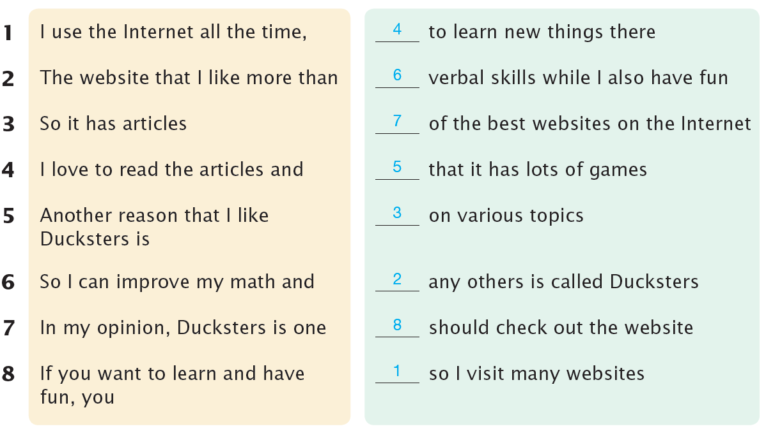
1. I use the Internet all the time, so I visit many websites.
2. The website that I like more than any others is called Ducksters.
3. So it has articles on various topics.
4. I love to read the articles and to learn new things there.
5. Another reason that I like Ducksters is that it has lots of games.
6. So I can improve my math and verbal skills while I also have fun.
7. In my opinion, Ducksters is one of the best websites on the Internet.
8. If you want to learn and have fun, you should check out the website.

Unit 3 My Most Memorable Trip

A
2. Korea is a country where you can enjoy four seasons.
3. Hawaii is a place where many people spend their vacations.
4. India is a country where there are many traditions and a lot of culture.

B
2. I had never eaten traditional Indian food before.
3. I had never seen such a beautiful sunset before.
4. I had never climbed to the top of a mountain before.

C
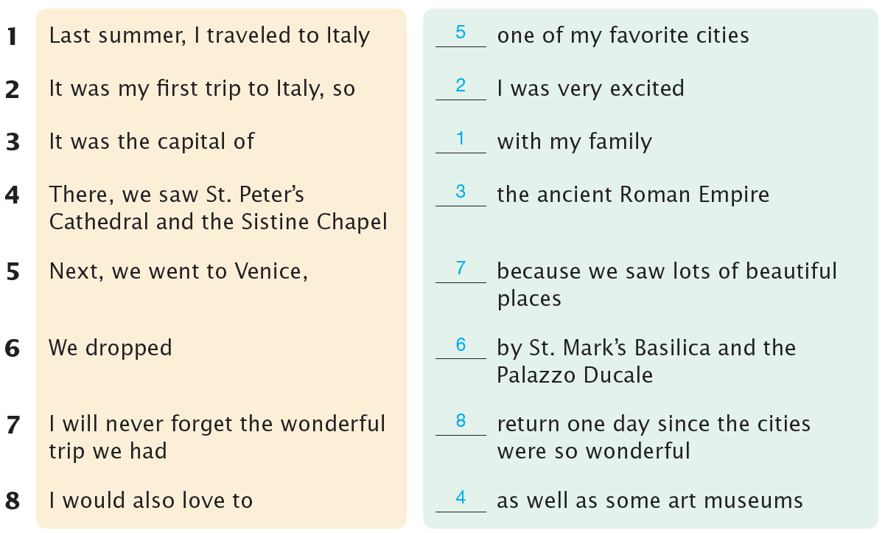
1. Last summer, I traveled to Italy with my family.
2. It was my first trip to Italy, so I was very excited.
3. It was the capital of the ancient Roman Empire.
4. There, we saw St. Peter’s Cathedral and the Sistine Chapel as well as some art museums.
5. Next, we went to Venice, one of my favorite cities.
6. We dropped by St. Mark’s Basilica and the Palazzo Ducale.
7. I will never forget the wonderful trip we had because we saw lots of beautiful places.
8. I would also love to return one day since the cities were so wonderful.

Unit 4 Famous People

A
2. One was the MVP award, which showed he was the best player.
3. One was David, which is a sculpture.
4. One was Ace Ventura: Pet Detective, which made audiences laugh a lot.

B
2. Whenever you think of basketball players, you should think of Michael Jordan.
3. Whenever you think of authors and educators, you should think of Helen Keller.
4. Whenever you think of artists, you should think of Michelangelo.

C
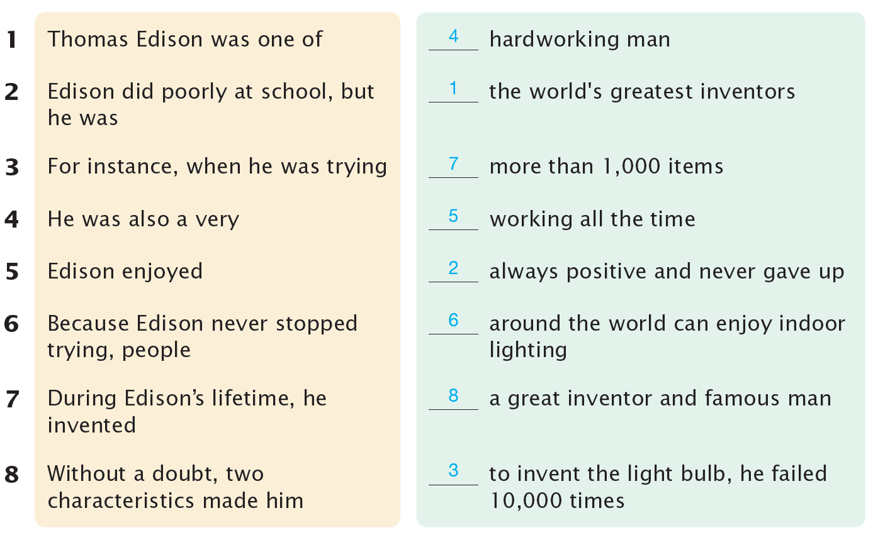
1. Thomas Edison was one of the world’s greatest inventors.
2. Edison did poorly at school, but he was always positive and never gave up.
3. For instance, when he was trying to invent the light bulb, he failed 10,000 times.
4. He was also a very hardworking man.
5. Edison enjoyed working all the time.
6. Because Edison never stopped trying, people around the world can enjoy indoor lighting.
7. During Edison’s lifetime, he invented more than 1,000 items.
8. Without a doubt, two characteristics made him a great inventor and famous man.

Unit 5 If I Were…

A
2. If I did that, customers would enjoy using my products.
3. If I found a cure for cancer, many patients might live longer.
4. If I bought my own private airplane, I could travel around the world.

B
2. As a CEO, I would take those actions.
3. As a doctor, I would do those activities.
4. As a writer, I would write those books.

C
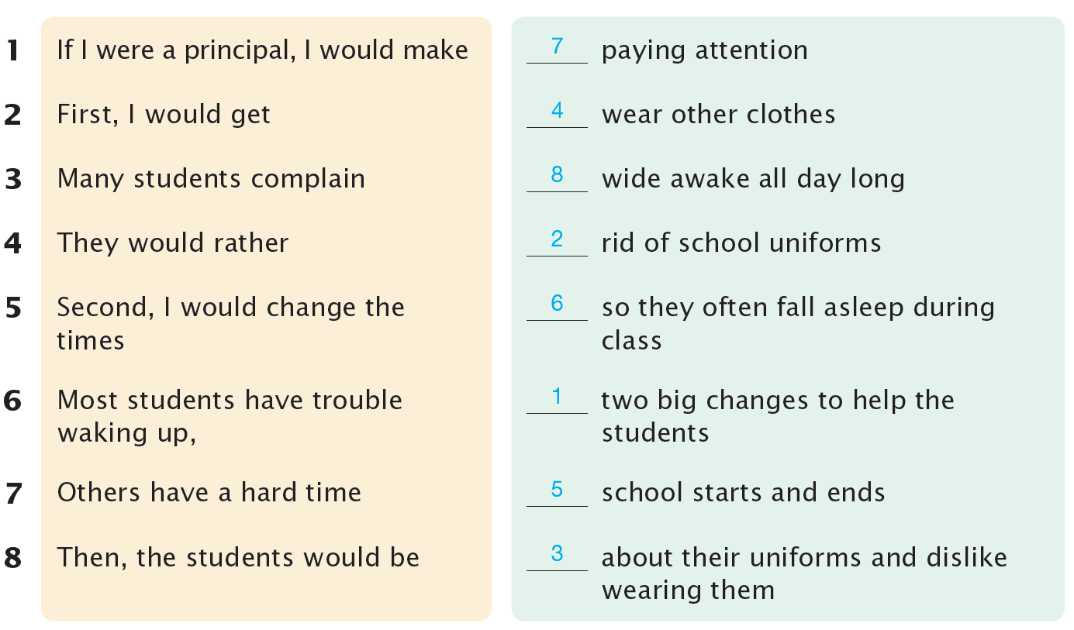
1. If I were a principal, I would make two big changes to help the students.
2. First, I would get rid of school uniforms.
3. Many students complain about their uniforms and dislike wearing them.
3. They would rather wear other clothes.
5. Second, I would change the times school starts and ends.
6. Most students have trouble waking up, so they often fall asleep during class.
7. Others have a hard time paying attention.
8. Then, the students would be wide awake all day long.

Unit 6 Taking Online Classes

A
2. While e-books are becoming popular, I still like paper books better.
3. While a long vacation sounds nice, it can be boring.
4. While studying abroad has its advantages, it also has its disadvantages.

B
2. E-books are far better than paper books.
3. A long vacation is even more exciting than several short vacations.
4. Studying alone is a lot more effective than studying in a group.

C
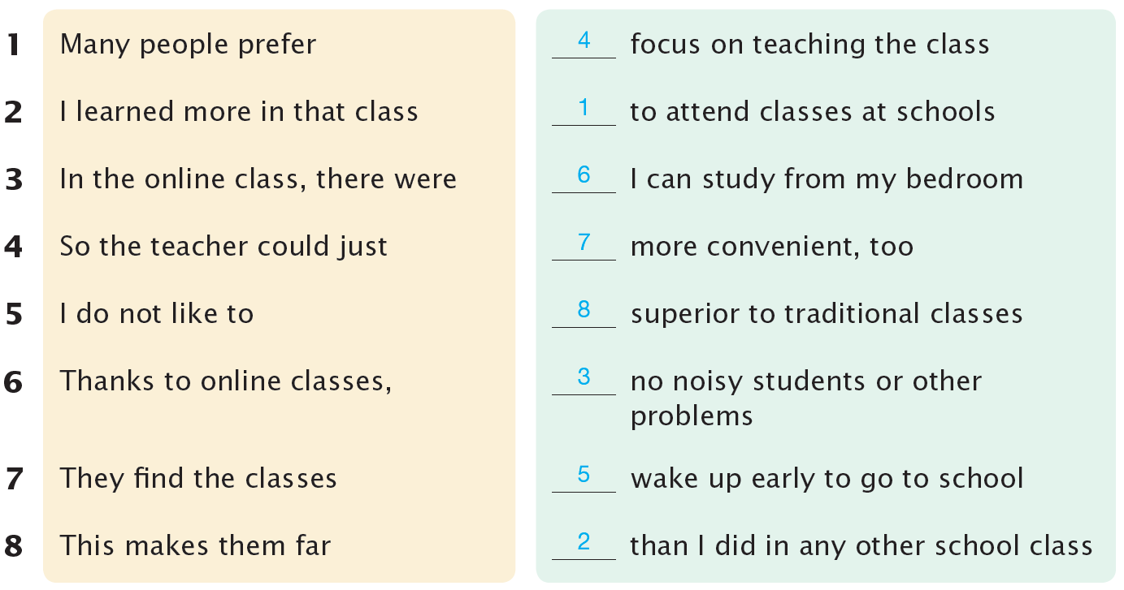
1. Many people prefer to attend classes at schools.
2. I learned more in that class than I did in any other school class.
3. In the online class, there were no noisy students or other problems.
4. So the teacher could just focus on teaching the class.
5. I do not like to wake up early to go to school.
6. Thanks to online classes, I can study from my bedroom.
7. They find the classes more convenient, too.
8. This makes them far superior to traditional classes.

Unit 7 The Environment

A
2. It seems that people know they should not waste food, but they are still doing it.
3. It seems that people know they should protect the environment, but they are not doing that.
4. It seems that people know they should not pollute, but they are still doing it.

B
2. The fossil fuels have been burned to create energy.
3. Almost half of the world’s rainforests have been destroyed.
4. Greenhouse gases have been produced by cows.

C
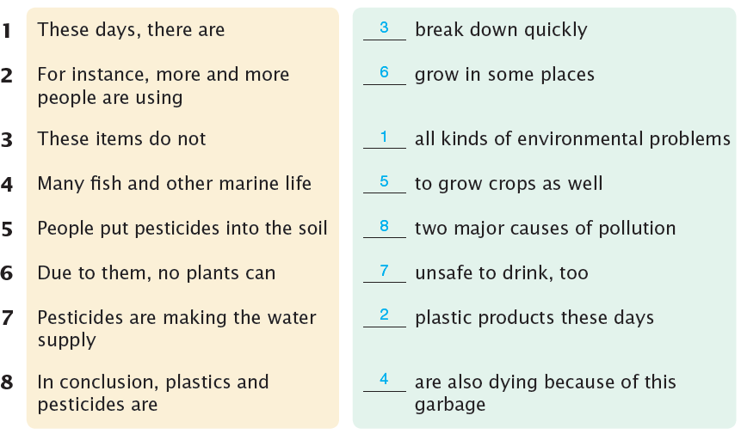
1. These days, there are all kinds of environmental problems.
2. For instance, more and more people are using plastic products these days.
3. These items do not break down quickly.
4. Many fish and other marine life are also dying because of this garbage.
5. People put pesticides into the soil to grow crops as well.
6. Due to them, no plants can grow in some places.
7. Pesticides are making the water supply unsafe to drink, too.
8. In conclusion, plastics and pesticides are two major causes of pollution.

Unit 8 Mobile Phones at Schools

A
2. Teens not only get valuable work experience but also learn how to deal with people.
3. Class discussions not only let students learn to speak better but also make students more confident.
4. Students not only do not have to buy many clothes but also do not worry about fashion.

B
2. The more they talk in class, the better their speaking skills get.
3. The more work they do, the more work experience they get.
4. The more homework they do every day, the more stress they have.

C
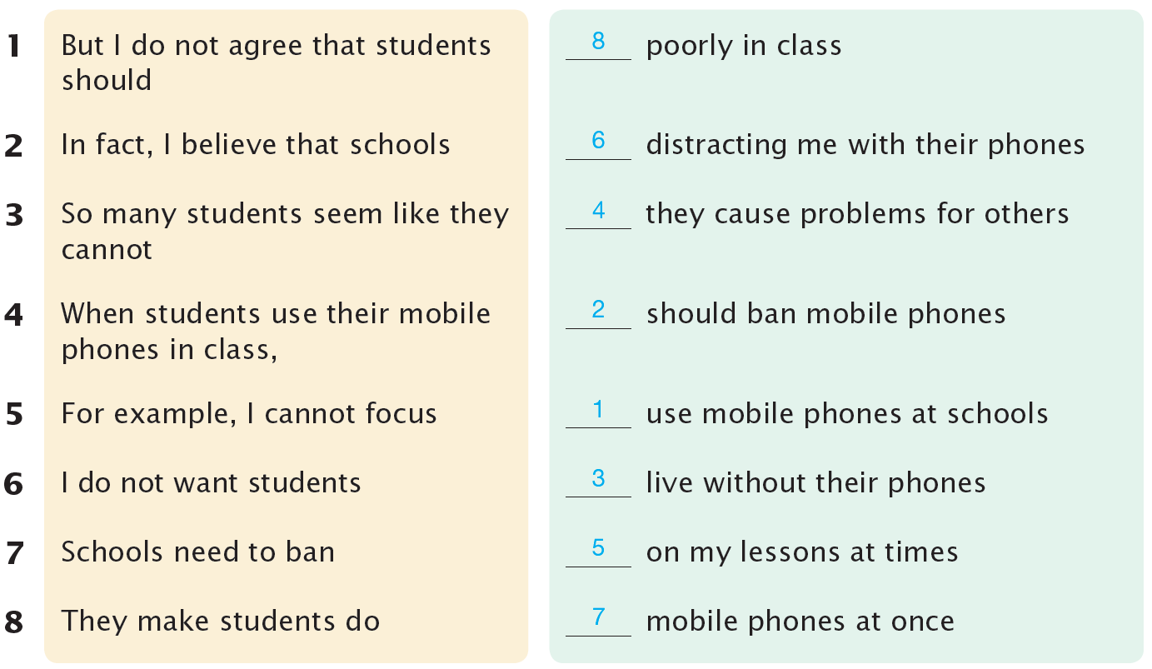
1. But I do not agree that students should use mobile phones at schools.
2. In fact, I believe that schools should ban mobile phones.
3. So many students seem like they cannot live without their phones.
4. When students use their mobile phones in class, they cause problems for others.
5. For example, I cannot focus on my lessons at times.
6. I do not want students distracting me with their phones.
7. Schools need to ban mobile phones at once.
8. They make students do poorly in class.

